SIMATS ENGINEERING
Name: Tejasri M
Register Number: 192511047
Course Code: CSA0313
Course: Data Structures
CO2 – ASSESSMENT TOOL 3

1. INSERT A NEW NODE AT THE END OF A SINGLY LINKED LIST
Idea:
Whenever we insert a node at the end of a singly linked list, the new node should become the last node. We first create a new node and store the data in it. Then we traverse the list until we reach the last node and connect the new node to it.
Steps:
- Create a new node using malloc().
- Read the data into temp->data.
- Set temp->next = NULL.
- If the list is empty, make root = temp.
- Otherwise, traverse until next == NULL.
- Connect the last node to the new node.
Simple diagram:
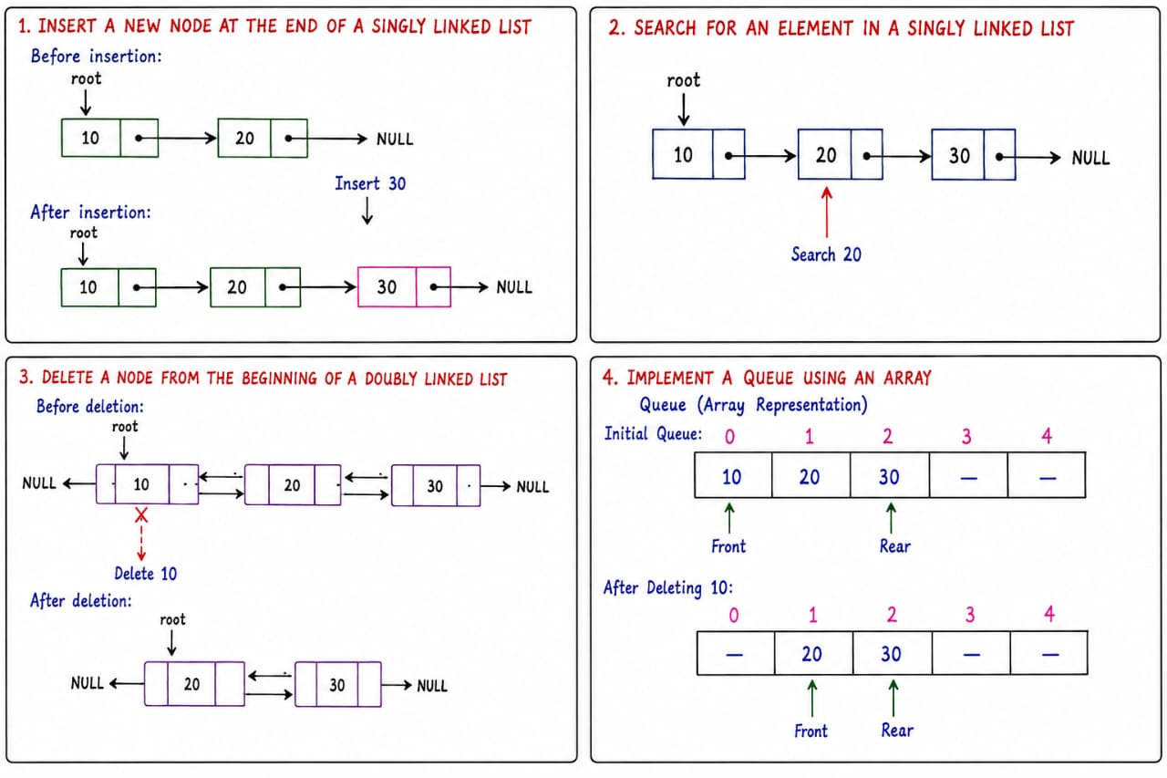
Program:
#include <stdio.h>
#include <stdlib.h>

struct node
{
int data;
struct node *next;
};

struct node *root = NULL;

void at_end()
{
struct node *temp, *ptr;

temp = (struct node*)malloc(sizeof(struct node));

printf("Enter node data: ");
scanf("%d", &temp->data);

temp->next = NULL;

if(root == NULL)
{
root = temp;
}
else
{
ptr = root;

while(ptr->next != NULL)
{
ptr = ptr->next;
}

ptr->next = temp;
}
}

void display()
{
struct node *ptr = root;

while(ptr != NULL)
{
printf("%d ", ptr->data);
ptr = ptr->next;
}
}

int main()
{
at_end();
at_end();
at_end();

printf("Linked List: ");
display();

return 0;
}
Dry Run:
Assume the list contains 10 and 20.

When 30 is inserted:

- Start from node 10.
- Move to node 20.
- Node 20 is the last node.
- Set 20->next = 30.
- The final list becomes 10 → 20 → 30.
Time Complexity:

O(n)

2. SEARCH FOR AN ELEMENT IN A SINGLY LINKED LIST
Idea:
To search for an element, we visit every node one by one and compare its data with the value we want to find. If the value matches, the element is found.
Steps:
- Set temp = root.
- Read the element to be searched.
- Compare temp->data with the search value.
- If they are equal, display that the element is found.
- Otherwise, move to the next node.
- Continue until temp == NULL.
Simple diagram:

Program:
#include <stdio.h>
#include <stdlib.h>

struct node
{
int data;
struct node *next;
};

struct node *root = NULL;

void insert()
{
struct node *temp, *ptr;

temp = (struct node*)malloc(sizeof(struct node));

printf("Enter data: ");
scanf("%d", &temp->data);

temp->next = NULL;

if(root == NULL)
{
root = temp;
}
else
{
ptr = root;

while(ptr->next != NULL)
{
ptr = ptr->next;
}

ptr->next = temp;
}
}

void search()
{
struct node *temp = root;
int key, position = 1;

printf("Enter element to search: ");
scanf("%d", &key);

while(temp != NULL)
{
if(temp->data == key)
{
printf("Element found at position %d", position);
return;
}

temp = temp->next;
position++;
}

printf("Element not found");
}

int main()
{
insert();
insert();
insert();

search();

return 0;
}
Dry Run:
Assume the list is:

10 → 20 → 30 → NULL

Search for 20.

- Compare 10 with 20 → Not equal.
- Move to 20.
- Compare 20 with 20 → Equal.
- Element is found at position 2.
Time Complexity:

O(n)

3. DELETE A NODE FROM THE BEGINNING OF A DOUBLY LINKED LIST
Idea:
When deleting the first node of a doubly linked list, the second node becomes the new first node. We update root to the second node and set its left pointer to NULL.
Steps:
- Check whether the list is empty.
- Store the first node in temp.
- Move root to the next node.
- Set root->left = NULL.
- Free the deleted node using free().
Simple diagram:

Program:
#include <stdio.h>
#include <stdlib.h>

struct node
{
int data;
struct node *left;
struct node *right;
};

struct node *root = NULL;

void delete_begin()
{
struct node *temp;

if(root == NULL)
{
printf("List is empty");
return;
}

temp = root;
root = root->right;

if(root != NULL)
{
root->left = NULL;
}

free(temp);
}

void display()
{
struct node *temp = root;

while(temp != NULL)
{
printf("%d ", temp->data);
temp = temp->right;
}
}

int main()
{
struct node *a, *b, *c;

a = (struct node*)malloc(sizeof(struct node));
b = (struct node*)malloc(sizeof(struct node));
c = (struct node*)malloc(sizeof(struct node));

a->data = 10;
b->data = 20;
c->data = 30;

a->left = NULL;
a->right = b;

b->left = a;
b->right = c;

c->left = b;
c->right = NULL;

root = a;

printf("Before deletion: ");
display();

delete_begin();

printf("\nAfter deletion: ");
display();

return 0;
}
Dry Run:
Initially:

10 ↔ 20 ↔ 30

- root points to 10.
- Store 10 in temp.
- Move root to 20.
- Set 20->left = NULL.
- Free node 10.
Final list:

20 ↔ 30
Time Complexity:
O(1)

4. IMPLEMENT A QUEUE USING AN ARRAY
Idea:
A queue follows the FIFO (First In First Out) principle. The element inserted first is removed first. In a queue, insertion is performed from the rear, while deletion is performed from the front.
Steps:
- Initialize front = -1 and rear = -1.
- For insertion, increase rear and store the element.
- For deletion, remove the element at front.
- Increase front after deletion.
- Check whether the queue is empty or full.
Simple diagram:

Program:
#include <stdio.h>

#define SIZE 5

int queue[SIZE];
int front = -1;
int rear = -1;

void enqueue(int value)
{
if(rear == SIZE - 1)
{
printf("Queue is full\n");
return;
}

if(front == -1)
{
front = 0;
}

rear++;
queue[rear] = value;

printf("%d inserted\n", value);
}

void dequeue()
{
if(front == -1 || front > rear)
{
printf("Queue is empty\n");
return;
}

printf("%d deleted\n", queue[front]);
front++;

if(front > rear)
{
front = -1;
rear = -1;
}
}

void display()
{
int i;

if(front == -1)
{
printf("Queue is empty\n");
return;
}

printf("Queue: ");

for(i = front; i <= rear; i++)
{
printf("%d ", queue[i]);
}

printf("\n");
}

int main()
{
enqueue(10);
enqueue(20);
enqueue(30);

display();

dequeue();

display();

return 0;
}
Dry Run:
Initially:

front = -1
rear = -1

Insert 10:

10

Insert 20:

10 20

Insert 30:

10 20 30

Delete operation removes 10 because it was inserted first.

Final queue:

20 30
Time Complexity:
- Enqueue: O(1)
- Dequeue: O(1)
- Display: O(n)

Summary
No. | Question | Time Complexity
1 | Insert at end – Singly Linked List | O(n)
2 | Search an element – Singly Linked List | O(n)
3 | Delete at beginning – Doubly Linked List | O(1)
4 | Queue using Array | O(1) for insertion/deletion

These follow the same overall structure as your uploaded material, which uses Idea, steps/logic, diagram, program, dry run, and time complexity.

